CNT 4703C, Brian Batinchok

Exam 2

There are Multiple-Choice and Free-Response questions on 9 pages. Do not leave any question unanswered. The total points is 110.

PART 1--Multiple-Choice Questions: circle the letter which corresponds to the correct answer from those listed. When a question is indicated as having more than one correct answer, circle only that many letters.

- Which of the following statements describes part of the process of how a switch decides to forward a frame destined for a known unicast MAC address?
  - It compares the unicast destination address to the bridging, or MAC address, table.
  - It compares the unicast source address to the bridging, or MAC address, table.
  - It forwards the frame out all interfaces in the same VLAN except for the incoming interface.
  - It compares the destination IP address to the destination MAC address.
  - It compares the frame’s incoming interface to the source MAC entry in the MAC address table.

- Which of the following statements best describes what a switch does with a frame destined for an unknown unicast address?
  - It forwards out all interfaces in the same VLAN except for the incoming interface.
  - It forwards the frame out the one interface identified by the matching entry in the MAC address table.
  - It compares the destination IP address to the destination MAC address.
  - It compares the frame’s incoming interface to the source MAC entry in the MAC address table.

- Which of the following comparisons does a switch make when deciding whether a new MAC address should be added to its MAC address table?
  - It compares the unicast destination address to the bridging, or MAC address, table.
  - It compares the unicast source address to the bridging, or MAC address, table.
  - It compares the VLAN ID to the bridging, or MAC address, table.
  - It compares the destination IP address’s ARP cache entry to the bridging, or MAC address, table.
- Imagine a switch with three configured VLANs. How many IP subnets are required, assuming that all hosts in all VLANs want to use TCP/IP?
  - 0
  - 1
  - 2
  - 3
  - You can’t tell from the information provided.

- Which of the following are functions of OSI Layer 3 protocols? (Choose two answers.)
a. Logical addressing
  - Physical addressing
  - Path selection
  - Arbitration
  - Error recovery

- Which of the following is a valid Class B IP address that can be assigned to a host?
a. 1.1.1.1
  - 200.1.1.1
  - 128.128.128.128
  - 224.1.1.1
  - 223.223.223.255

- What is the assignable range of values for the first octet for Class B IP networks?
- 0 to 127
- 0 to 126
- 1 to 127
- 1 to 126
- 128 to 191
- 128 to 192

- PC1 and PC2 are on two different Ethernet LANs that are separated by an IP router. PC1’s IP address is 10.2.2.2, and no subnetting is used. Which of the following addresses could be used for PC2? (Choose two answers.)
  - 10.1.1.1
  - 10.1.1.2
  - 10.200.200.1
  - 9.1.1.1
  - 225.1.1.1
  - 1.1.1.1

- Imagine a network with two routers that are connected with a point-to-point HDLC serial link. Each router has an Ethernet, with PC1 sharing the Ethernet with Router1 and PC2 sharing the Ethernet with Router2. When PC1 sends data to PC2, which of the following is true?
  - Router1 strips the Ethernet header and trailer off the frame received from PC1, never to be used again.
  - Router1 encapsulates the Ethernet frame inside an HDLC header and sends the frame to Router2, which extracts the Ethernet frame for forwarding to PC2.
  - Router1 strips the Ethernet header and trailer off the frame received from PC1, which is exactly re-created by Router2 before forwarding data to PC2.
  - Router1 removes the Ethernet, IP, and TCP headers and rebuilds the appropriate headers before forwarding the packet to Router2.

- Which of the following does a router normally use when making a decision about routing TCP/IP packets?
  - Destination MAC address
  - Source MAC address
  - Destination IP address
  - Source IP address
  - Destination MAC and IP address

- Which of the following are true about a LAN-connected TCP/IP host and its IP routing
(forwarding) choices? (Choose two answers.)
  - The host always sends packets to its default gateway.
  - The host sends packets to its default gateway if the destination IP address is in a different class of IP network than the host.
  - The host sends packets to its default gateway if the destination IP address is in a different subnet than the host.
  - The host sends packets to its default gateway if the destination IP address is in the same subnet as the host.

- Which of the following is NOT a function of LAN switch?
  - Deciding when to forward or filter (not forward) a frame, based on the destination MAC address.
  - Concerning itself with the logical details of delivering data, from the source host to the destination host based on the IP address in the packet.
  - Learning MAC addresses by examining the source MAC address of each frame received by the switch.
  - Creating a (Layer 2) loop-free environment with other bridges by using Spanning Tree Protocol (STP).

Question 13 and 14, refer to the exhibit:

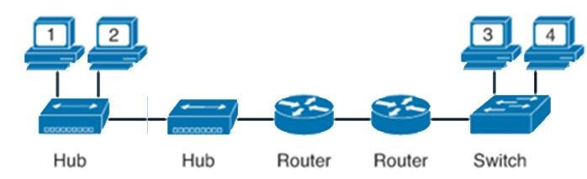

- How many collision domains in this network?
  - 1.
  - 2.
  - 3.
  - 4.
  - 5.
  - 6.

- How many broadcast domains in this network?
  - 1.
  - 2.
  - 3.
  - 4.
  - 5.
  - 6.

- On corporate network, hosts on the same VLAN can communicate with each other, but they are unable to communicate with hosts on different VLANs. What is needed to allow communication between the VLANs?
  - A router with subinterfaces configured on the physical interface that is connected to the switch.
  - A router with an IP address on the physical interface connected to the switch 2.
  - A switch with an access link that is configured between the switches.
  - A switch with a trunk link that is configured between the switches.

- Refer to the exhibit:
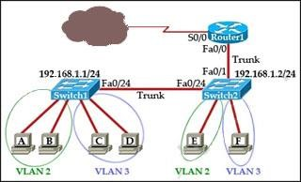

Which two statements are true about interVLAN routing in the topology that is shown in the exhibit? (Choose two)
  - Host E and host F use the same IP gateway address.
  - Routed and Switch2 should be connected via a crossover cable.
  - Router1 will not play a role in communications between host A and host D.
  - The FastEthernet 0/0 interface on Router1 must be configured with subinterfaces.
  - Router1 needs more LAN interfaces to accommodate the VLANs that are shown in the exhibit.
  - The FastEthernet 0/0 interface on Router1 and Switch2 trunk ports must be configured using the same encapsulation type.
- Refer to the exhibit:
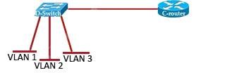
C-router is to be used as a “router-on-a-stick” to route between the VLANs. It has been configured with subinterfaces as follows:
F0/0.1 – 172.19.1.245/24 VLAN 1
F0/0.2 – 172.19.2.245/24 VLAN 2
F0/0.3 – 172.19.3.245/24 VLAN 3
All the interfaces have been properly configured and IP routing is operational. The hosts in the VLANs have been configured with the appropriate default gateway. What can be said about this configuration?
  - These commands need to be added to the configuration:
C-router(config)# router eigrp 123
C-router(config-router)# network 172.19.0.0

  - No further routing configuration is required.

  - These commands need to be added to the configuration:
C-router(config)# router ospf 1
C-router(config-router)# network 172.19.0.0 0.0.3.255 area 0

  - These commands need to be added to the configuration:
C-router(config)# router rip
C-router(config-router)# network 172.19.0.0
- Refer to the exhibit:
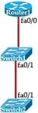
The FastEthernet0/1 port on the 2950 model switches that are shown in the exhibit needs to be configured trunk to carry multiple VLAN traffic to allow connectivity between all devices. How should the ports be configured?
  - The ports only need to be connected by a crossover cable.

  - SwitchX (config)#interface FastEthernet 0/1
SwitchX(config-if)#switchport mode trunk

  - SwitchX (config)#interface FastEthernet 0/1
SwitchX(config-if)#switchport mode access
SwitchX(config-if)#switchport access vlan 1

  - SwitchX (config)#interface FastEthernet 0/1
SwitchX(config-if)#switchport mode trunk
SwitchX(config-if)#switchport trunk vlan 1
SwitchX(config-if)#switchport trunk vlan 10
SwitchX(config-if)#switchport trunk vlan 20

Part 2--Free-response Questions:
- Configure IP addresses (do not forget subnet masks) for the interfaces and the PC in this network.
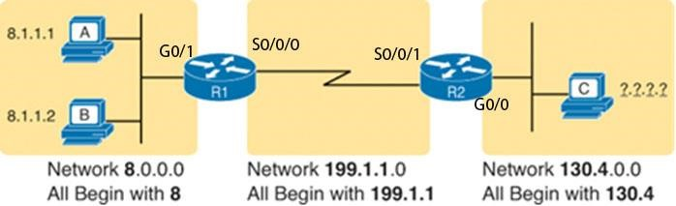

R1: G0/1: 8.1.1.254/24
S0/0/0: 199.1.1.1/30
R2: S0/0/1: 199.1.1.2/30
G0/0: 130.4.0.254/24
PC C: NIC: 130.4.0.1

- Refer to the exhibit:
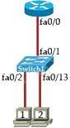
The current configurations of the devices are as follows:
Switch 1:
IP address: 192.168.1.2/24
Ports 2-12 VLAN 10
Ports 13-24 VLAN 20
Host 1:
IP address: 192.168.10.5/24
Default Gateway: 192.168.10.1

Host 2:
IP address: 192.168.20.5/24
Default Gateway: 192.168.20.1

What commands must be configured on the switch and the router to allow communication between host 1 and host 2? (Configure mode trunk for f0/1 of the switch, and subinterfaces for f0/0 of the router):
Router:
enable
conf t
int f0/0
no shut
int f0/0.10
encapsulation dot1Q 10
ip address 192.168.10.1 255.255.255.0
int g0/0.20
encapsulation dot1Q 20
ip address 192.168.20.1 255.255.255.0

Switch:
Enable
configure terminal
vlan 10
name vlan10
vlan 20
name vlan20
interface range fa0/2-12
switchport mode access
switchport access vlan 10
interface range fa0/13-24
switchport mode access
switchport access vlan 20
interface fa0/1
switchport mode trunk
switchport trunk allowed vlan 1-20

Corrections:

8: d f
R1: G0/1: 8.1.1.3/8 S0/0/0: 199.1.1.1/24
R2: S0/0/1: 199.1.1.2/24
G0/0: 130.4.1.1/16 PC C:
NIC: 130.4.1.2/16

